XKAR(Pakistan)

Please see the below Manual steps of Pakistan Stock Exchange (XKAR).
First Source Link - https://dps.psx.com.pk/

- In the highlighted tab click both DELIVERABLE FUTURES CONTRACT & CASH SETTLED FUTURES CONTRACT Copy and paste the entire content in excel from the website
- Click the down arrow in month and we should cover all the months
- Click the next page tab and we have to scrap the entire data
- Both Deliverable Futures Contracts and Cash Settled Futures Contracts should be merged into a single file.
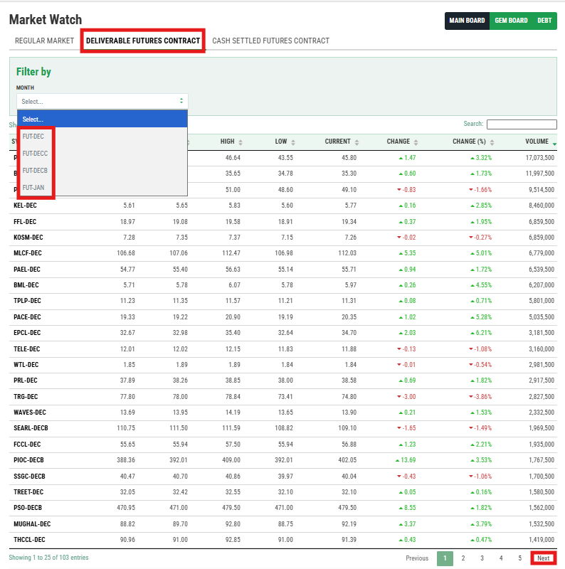

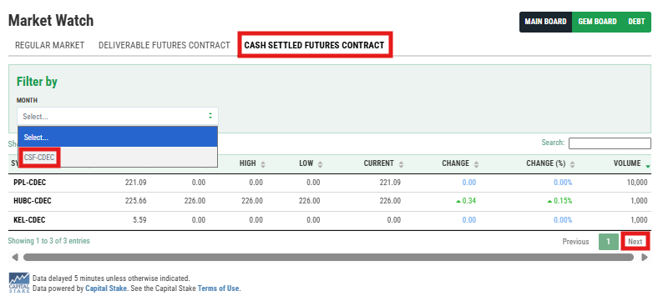
Open Interest Data Link: https://dps.psx.com.pk/downloads
- Click the Daily Downloads & Check the today date in the dates tab
- Download the Symbol Wise Open Interest (DFC) & Symbol Wise Open Interest (CSF) in PDF Format in Futures Market
- The first source link symbol header and the Open Interest Data Link Name header are both the same. Comparing symbols, could you please add the open interest data on the right side of the Excel ( Symbol Category, Open Interest in number of Contracts, Open Interest in volume, Open Interest in value, Free Float of Scrips in volume & % of Free Float)

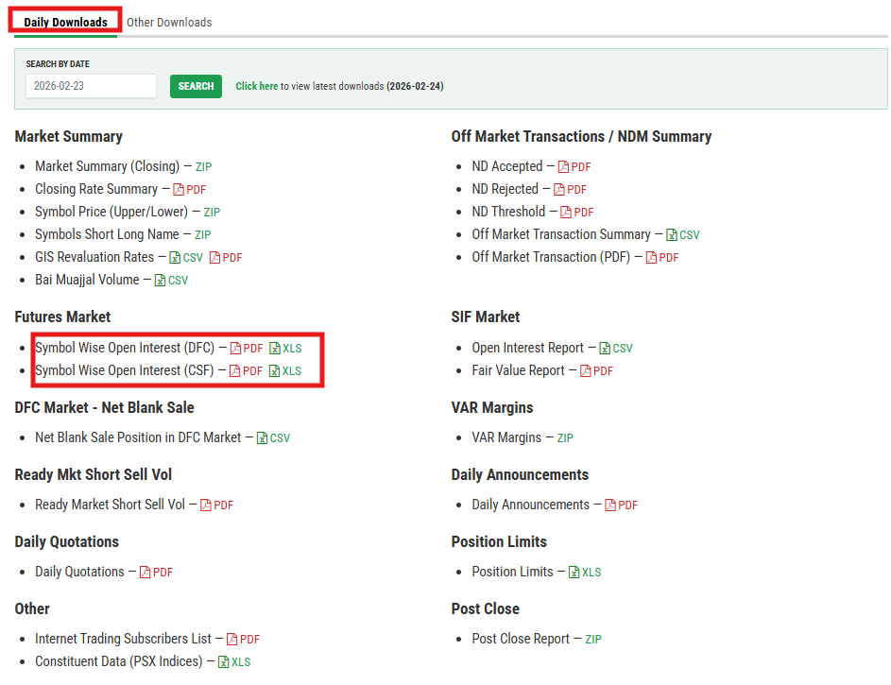

Contract Name:

- Contract Name column to be added into right side of the excel
- For DELIVERABLE FUTURES CONTRACT in Market Summary Download the Zip format in Symbols Short Long Name
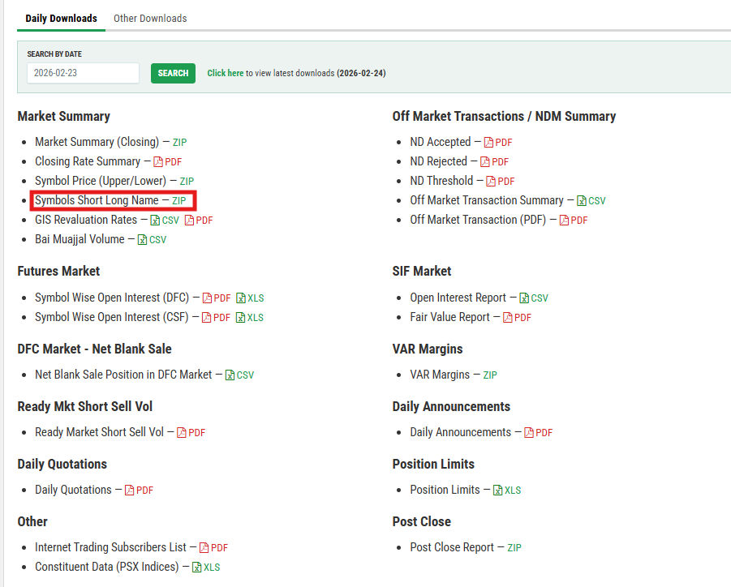
Split the symbols with the contract name
Add the Full Contract Name for DELIVERABLE FUTURES CONTRACT comparing with Symbols

For Ex:
﻿Symbol: CNERGY-FEB
Contract Name: ﻿Cnergyico PK Limited

﻿
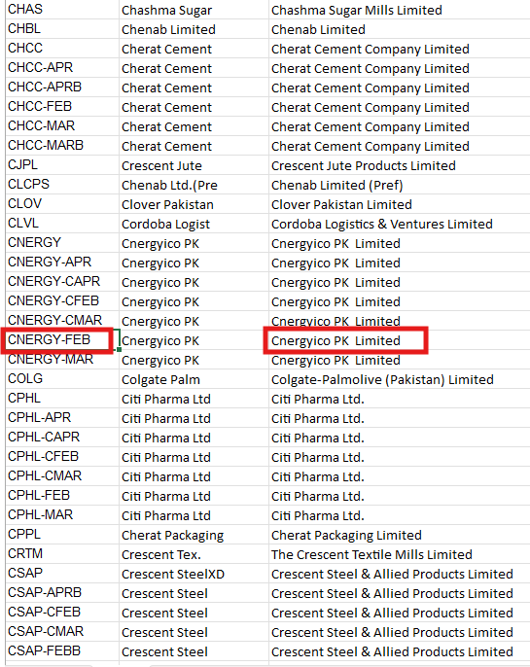

- For CASH SETTLED FUTURES CONTRACT in Daily Quotations Download the PDF format
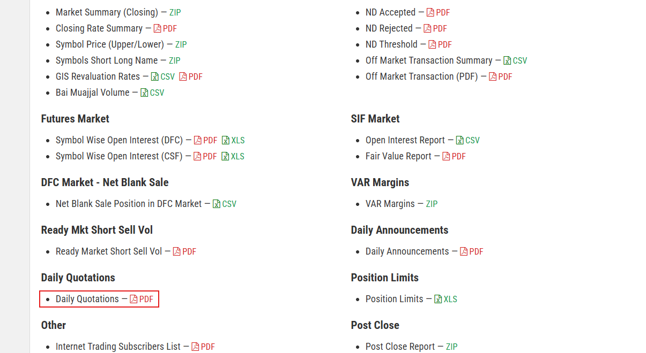

- Click the Section 9 : Future Contracts
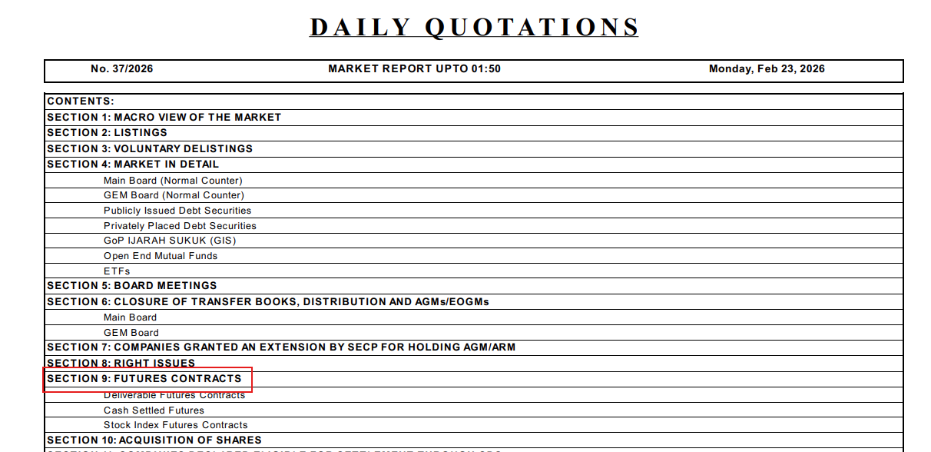

- Company Name should be taken as Contract Name Compare with Symbol code
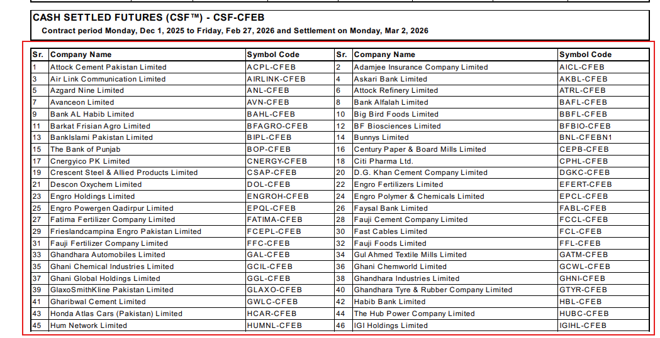

DFC Expiration date:
- Expiration Date column to be added into right side of the excel
- For DELIVERABLE FUTURES CONTRACT Click the Daily Quotations => Section 9 => Future contracts
- Based on the month in the symbols, we should determine the expiration date.
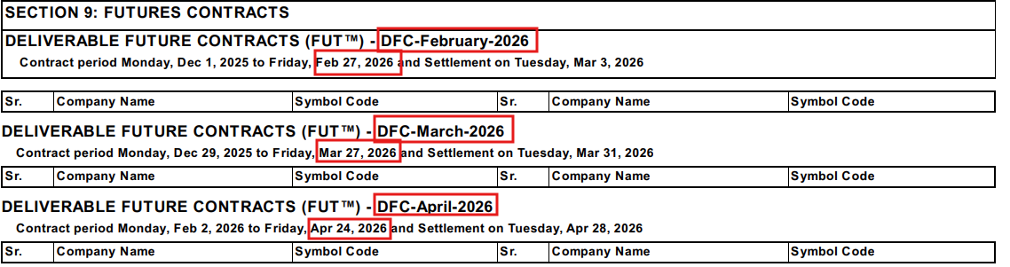

CSF Expiration date:
- Click Section 9 => Future contracts
- Based on the Symbol Code, we should determine the expiration date.
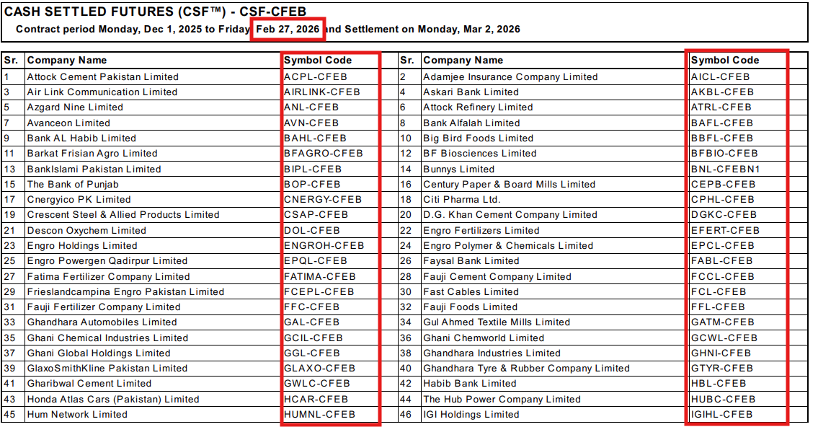
- Some of the Symbol Code has Expiration Date in Closing of Contracts
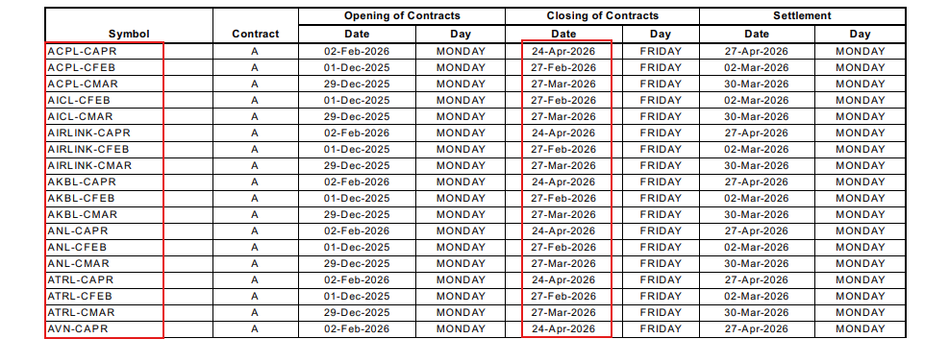

Expiration Date Format should be - YYYY-MM-DD
Output file name Format should be -XKAR_YYYYMMDD
XKAR Template :

